PROJECT REPORT
  INDIA GENERAL ELECTIONS RESULT ANALYSIS 2024  [Document subtitle] | Abstract  "India General Elections Result Analysis 2024 Using SQL" examines election data to reveal voting patterns, party performance, and regional trends. By utilizing SQL for data querying and analysis, the project highlights key metrics like voter turnout and seat share, providing valuable insights into the electoral landscape and data-driven conclusions.

Table of Contents
1. Introduction
- Overview of India Elections 2024 Dataset
- Objectives of the Analysis
2. Data Structure and Schema
- Description of Tables
  - constituencywise_details
  - constituencywise_results
  - partywise_results
  - statewise_results
  - states
- Schema of Tables
3. Key Analysis and Queries
3.1 General Overview
- Total Seats
  - Query: What is the total number of seats available for elections in each state?
3.2 Performance by Alliances
- Total Seats Won by NDA Alliance
  - Query: Total seats won by NDA alliance across all states.
- Seats Won by NDA Alliance Parties
  - Query: Breakdown of seats won by individual NDA parties.
- Total Seats Won by I.N.D.I.A Alliance
  - Query: Total seats won by I.N.D.I.A alliance across all states.
- Seats Won by I.N.D.I.A Alliance Parties
  - Query: Breakdown of seats won by individual I.N.D.I.A alliance parties.
- Most Successful Alliance
  - Query: Which party alliance (NDA, I.N.D.I.A, or OTHER) won the most seats across all states?
3.3 Modifying the Dataset
- Adding Party Alliance Field
  - Task: Add a new column in partywise_results to specify party alliances (NDA, I.N.D.I.A, OTHER).
3.4 Constituency-Level Analysis
- Winning Candidate Details
  - Query: Winning candidate's name, their party name, total votes, and the margin of victory for a specific state and constituency.
- EVM vs Postal Votes Distribution
  - Query: Distribution of EVM votes versus postal votes for candidates in a specific constituency.
- Top Performers by Votes
  - Query: Candidates with the highest EVM votes in each constituency (Top 10).
- Winner and Runner-Up Details
  - Query: Identify the winner and runner-up in each constituency for the 2024 elections.
3.5 State-Level Insights
- Party Performance by State
  - Query: Which parties won the most seats in a state and the number of seats won by each?
- Seats by Alliance in Each State
  - Query: Total seats won by each party alliance (NDA, I.N.D.I.A, OTHER) in each state for the India Elections 2024.
- Uttar Pradesh Analysis
  - Query: For Uttar Pradesh, calculate:
    - Total number of seats
    - Total number of candidates
    - Total number of parties
    - Total votes (including EVM and postal)
    - Breakdown of EVM and postal votes
4. Summary and Insights
- Key Findings from the Queries
- Most Successful Parties and Alliances
- Regional Variations in Performance
5. Recommendations
- Suggestions for Data Improvement
- Potential Applications of Insights
6. Conclusion
- Final Observations on the India Elections 2024.

Key Findings from the Queries
    - Total Seats

    - What is the total number of seats available for elections in each state ?

    - Total Seats Won by NDA Allianz

    - Seats Won by NDA Allianz Parties

    - Total Seats Won by I.N.D.I.A. Allianz

    - Seats Won by I.N.D.I.A. Allianz Parties

    - Add new column field in table partywise_results to get the Party Allianz as NDA, I.N.D.I.A and OTHER

    - Which party alliance (NDA, I.N.D.I.A, or OTHER) won the most seats across all states?

    - Winning candidate's name, their party name, total votes, and the margin of victory for a specific state and constituency?

    - What is the distribution of EVM votes versus postal votes for candidates in a specific constituency?

    - Which parties won the most seats in s State, and how many seats did each party win?

    - What is the total number of seats won by each party alliance (NDA, I.N.D.I.A, and OTHER) in each state for the India Elections 2024

    - Which candidate received the highest number of EVM votes in each constituency (Top 10)?

    - Which candidate won and which candidate was the runner-up in each constituency of State for the 2024 elections?

    - For the state of Uttar Pradesh, what are the total number of seats, total number of candidates, total number of parties, total votes (including EVM and postal), and the breakdown of EVM and postal votes?

INDIA GENERAL ELECTIONS RESULT SHOW TABLES

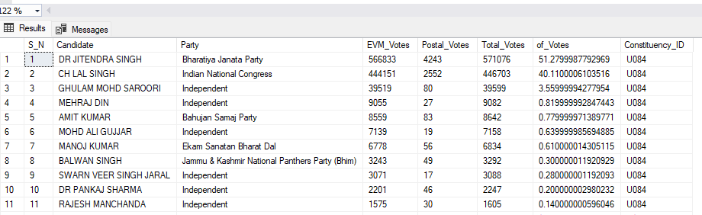
SELECT * FROM constituencywise_details

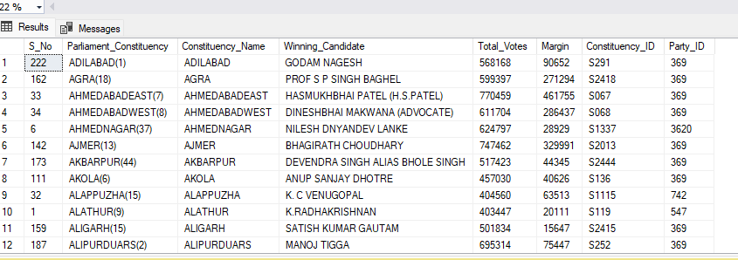
SELECT * FROM constituencywise_results

SELECT * FROM partywise_results

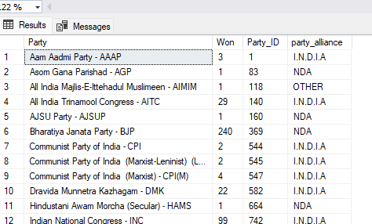

SELECT * FROM statewise_results
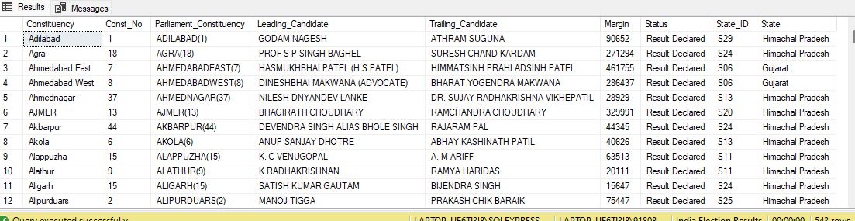

SELECT * FROM states

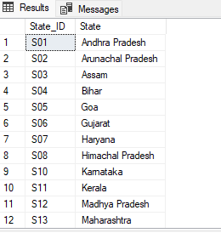

INDIA GENERAL ELECTIONS RESULT ANALYSIS 2024
Total Seats
SELECT
DISTINCT COUNT (Parliament_Constituency) AS Total_Seats
FROM constituencywise_results
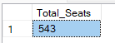

What is the total number of seats available for elections in each state ?
SELECT
s.State AS State_Name,
COUNT(cr.Constituency_ID) AS Total_Seats_Available
FROM
constituencywise_results cr
JOIN
statewise_results sr ON cr.Parliament_Constituency = sr.Parliament_Constituency
JOIN
states s ON sr.State_ID = s.State_ID
GROUP BY
s.State
ORDER BY
s.State;

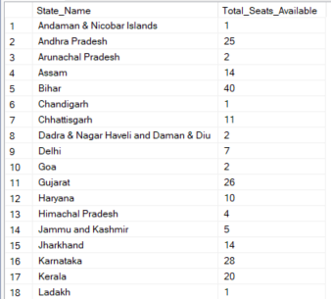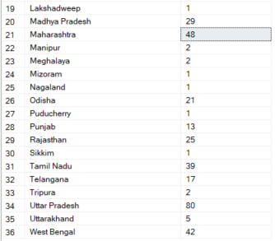
Total Seats Won by NDA Allianz
SELECT
SUM(CASE
WHEN party IN (
'Bharatiya Janata Party - BJP',
'Telugu Desam - TDP',
'Janata Dal (United) - JD(U)',
'Shiv Sena - SHS',
'AJSU Party - AJSUP',
'Apna Dal (Soneylal) - ADAL',
'Asom Gana Parishad - AGP',
'Hindustani Awam Morcha (Secular) - HAMS',
'Janasena Party - JnP',
'Janata Dal (Secular) - JD(S)',
'Lok Janshakti Party(Ram Vilas) - LJPRV',
'Nationalist Congress Party - NCP',
'Rashtriya Lok Dal - RLD',
'Sikkim Krantikari Morcha - SKM'
) THEN [Won]
ELSE 0
END) AS NDA_Total_Seats_Won
FROM
partywise_results

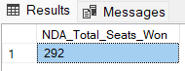

Seats Won by NDA Allianz Parties
SELECT
party as Party_Name,
won as Seats_Won
FROM
partywise_results
WHERE
party IN (
'Bharatiya Janata Party - BJP',
'Telugu Desam - TDP',
'Janata Dal (United) - JD(U)',
'Shiv Sena - SHS',
'AJSU Party - AJSUP',
'Apna Dal (Soneylal) - ADAL',
'Asom Gana Parishad - AGP',
'Hindustani Awam Morcha (Secular) - HAMS',
'Janasena Party - JnP',
'Janata Dal (Secular) - JD(S)',
'Lok Janshakti Party(Ram Vilas) - LJPRV',
'Nationalist Congress Party - NCP',
'Rashtriya Lok Dal - RLD',
'Sikkim Krantikari Morcha - SKM'
)
ORDER BY Seats_Won DESC
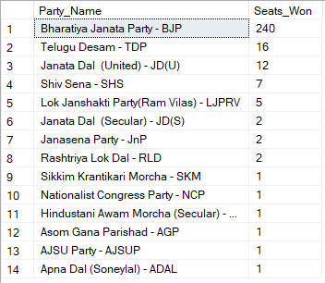
Total Seats Won by I.N.D.I.A. Allianz
SELECT
SUM(CASE
WHEN party IN (
'Indian National Congress - INC',
'Aam Aadmi Party - AAAP',
'All India Trinamool Congress - AITC',
'Bharat Adivasi Party - BHRTADVSIP',
'Communist Party of India (Marxist) - CPI(M)',
'Communist Party of India (Marxist-Leninist) (Liberation) - CPI(ML)(L)',
'Communist Party of India - CPI',
'Dravida Munnetra Kazhagam - DMK',
'Indian Union Muslim League - IUML',
'Nat`Jammu & Kashmir National Conference - JKN',
'Jharkhand Mukti Morcha - JMM',
'Jammu & Kashmir National Conference - JKN',
'Kerala Congress - KEC',
'Marumalarchi Dravida Munnetra Kazhagam - MDMK',
'Nationalist Congress Party Sharadchandra Pawar - NCPSP',
'Rashtriya Janata Dal - RJD',
'Rashtriya Loktantrik Party - RLTP',
'Revolutionary Socialist Party - RSP',
'Samajwadi Party - SP',
'Shiv Sena (Uddhav Balasaheb Thackrey) - SHSUBT',
'Viduthalai Chiruthaigal Katchi - VCK'
) THEN [Won]
ELSE 0
END) AS INDIA_Total_Seats_Won
FROM
partywise_results

Seats Won by I.N.D.I.A. Allianz Parties
SELECT
party as Party_Name,
won as Seats_Won
FROM
partywise_results
WHERE
party IN (
'Indian National Congress - INC',
'Aam Aadmi Party - AAAP',
'All India Trinamool Congress - AITC',
'Bharat Adivasi Party - BHRTADVSIP',
'Communist Party of India (Marxist) - CPI(M)',
'Communist Party of India (Marxist-Leninist) (Liberation) - CPI(ML)(L)',
'Communist Party of India - CPI',
'Dravida Munnetra Kazhagam - DMK',
'Indian Union Muslim League - IUML',
'Nat`Jammu & Kashmir National Conference - JKN',
'Jharkhand Mukti Morcha - JMM',
'Jammu & Kashmir National Conference - JKN',
'Kerala Congress - KEC',
'Marumalarchi Dravida Munnetra Kazhagam - MDMK',
'Nationalist Congress Party Sharadchandra Pawar - NCPSP',
'Rashtriya Janata Dal - RJD',
'Rashtriya Loktantrik Party - RLTP',
'Revolutionary Socialist Party - RSP',
'Samajwadi Party - SP',
'Shiv Sena (Uddhav Balasaheb Thackrey) - SHSUBT',
'Viduthalai Chiruthaigal Katchi - VCK'
)
ORDER BY Seats_Won DESC
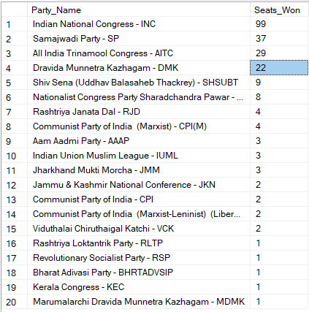
Add new column field in table partywise_results to get the Party Allianz as NDA, I.N.D.I.A and OTHER
ALTER TABLE partywise_results
ADD party_alliance VARCHAR(50);
I.N.D.I.A Allianz
UPDATE partywise_results
SET party_alliance = 'I.N.D.I.A'
WHERE party IN (
'Indian National Congress - INC',
'Aam Aadmi Party - AAAP',
'All India Trinamool Congress - AITC',
'Bharat Adivasi Party - BHRTADVSIP',
'Communist Party of India (Marxist) - CPI(M)',
'Communist Party of India (Marxist-Leninist) (Liberation) - CPI(ML)(L)',
'Communist Party of India - CPI',
'Dravida Munnetra Kazhagam - DMK',
'Indian Union Muslim League - IUML',
'Jammu & Kashmir National Conference - JKN',
'Jharkhand Mukti Morcha - JMM',
'Kerala Congress - KEC',
'Marumalarchi Dravida Munnetra Kazhagam - MDMK',
'Nationalist Congress Party Sharadchandra Pawar - NCPSP',
'Rashtriya Janata Dal - RJD',
'Rashtriya Loktantrik Party - RLTP',
'Revolutionary Socialist Party - RSP',
'Samajwadi Party - SP',
'Shiv Sena (Uddhav Balasaheb Thackrey) - SHSUBT',
'Viduthalai Chiruthaigal Katchi - VCK'
);
NDA Allianz
UPDATE partywise_results
SET party_alliance = 'NDA'
WHERE party IN (
'Bharatiya Janata Party - BJP',
'Telugu Desam - TDP',
'Janata Dal (United) - JD(U)',
'Shiv Sena - SHS',
'AJSU Party - AJSUP',
'Apna Dal (Soneylal) - ADAL',
'Asom Gana Parishad - AGP',
'Hindustani Awam Morcha (Secular) - HAMS',
'Janasena Party - JnP',
'Janata Dal (Secular) - JD(S)',
'Lok Janshakti Party(Ram Vilas) - LJPRV',
'Nationalist Congress Party - NCP',
'Rashtriya Lok Dal - RLD',
'Sikkim Krantikari Morcha - SKM'
);
OTHER
UPDATE partywise_results
SET party_alliance = 'OTHER'
WHERE party_alliance IS NULL;

Which party alliance (NDA, I.N.D.I.A, or OTHER) won the most seats across all states?
SELECT
p.party_alliance,
COUNT(cr.Constituency_ID) AS Seats_Won
FROM
constituencywise_results cr
JOIN
partywise_results p ON cr.Party_ID = p.Party_ID
WHERE
p.party_alliance IN ('NDA', 'I.N.D.I.A', 'OTHER')
GROUP BY
p.party_alliance
ORDER BY
Seats_Won DESC;

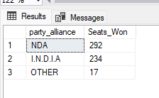

Winning candidate's name, their party name, total votes, and the margin of victory for a specific state and constituency?
SELECT cr.Winning_Candidate, p.Party, p.party_alliance, cr.Total_Votes, cr.Margin, cr.Constituency_Name, s.State
FROM constituencywise_results cr
JOIN partywise_results p ON cr.Party_ID = p.Party_ID
JOIN statewise_results sr ON cr.Parliament_Constituency = sr.Parliament_Constituency
JOIN states s ON sr.State_ID = s.State_ID
WHERE s.State = 'Uttar Pradesh' AND cr.Constituency_Name = 'GORAKHPUR';
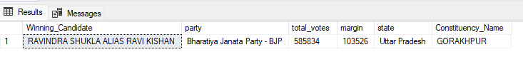
What is the distribution of EVM votes versus postal votes for candidates in a specific constituency?

SELECT
cd.Candidate,
cd.Party,
cd.EVM_Votes,
cd.Postal_Votes,
cd.Total_Votes,
cr.Constituency_Name
FROM
constituencywise_details cd
JOIN
constituencywise_results cr ON cd.Constituency_ID = cr.Constituency_ID
WHERE
cr.Constituency_Name = 'KANPUR'
ORDER BY cd.Total_Votes DESC;
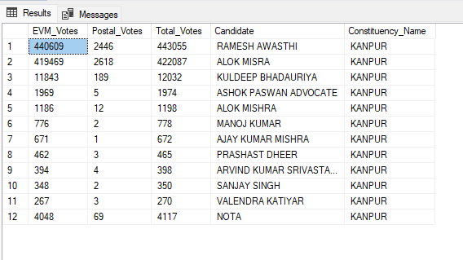

Which parties won the most seats in s State, and how many seats did each party win?
SELECT
p.Party,
COUNT(cr.Constituency_ID) AS Seats_Won
FROM
constituencywise_results cr
JOIN
partywise_results p ON cr.Party_ID = p.Party_ID
JOIN
statewise_results sr ON cr.Parliament_Constituency = sr.Parliament_Constituency
JOIN states s ON sr.State_ID = s.State_ID
WHERE
s.state = 'Bihar'
GROUP BY
p.Party
ORDER BY
Seats_Won DESC;
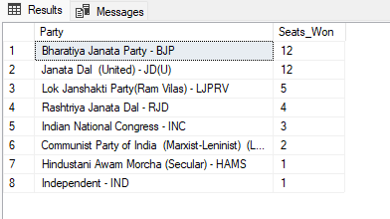

What is the total number of seats won by each party alliance (NDA, I.N.D.I.A, and OTHER) in each state for the India Elections 2024 ?
SELECT
s.State AS State_Name,
SUM(CASE WHEN p.party_alliance = 'NDA' THEN 1 ELSE 0 END) AS NDA_Seats_Won,
SUM(CASE WHEN p.party_alliance = 'I.N.D.I.A' THEN 1 ELSE 0 END) AS INDIA_Seats_Won,
SUM(CASE WHEN p.party_alliance = 'OTHER' THEN 1 ELSE 0 END) AS OTHER_Seats_Won
FROM
constituencywise_results cr
JOIN
partywise_results p ON cr.Party_ID = p.Party_ID
JOIN
statewise_results sr ON cr.Parliament_Constituency = sr.Parliament_Constituency
JOIN
states s ON sr.State_ID = s.State_ID
WHERE
p.party_alliance IN ('NDA', 'I.N.D.I.A', 'OTHER') -- Filter for NDA and INDIA alliances
GROUP BY
s.State
ORDER BY
s.State;

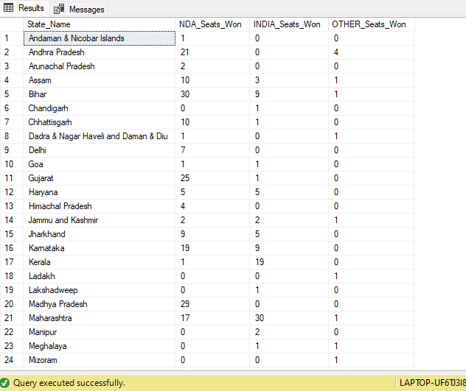

Which candidate received the highest number of EVM votes in each constituency (Top 10)?
SELECT TOP 10
cr.Constituency_Name,
cd.Constituency_ID,
cd.Candidate,
cd.EVM_Votes
FROM
constituencywise_details cd
JOIN
constituencywise_results cr ON cd.Constituency_ID = cr.Constituency_ID
WHERE
cd.EVM_Votes = (
SELECT MAX(cd1.EVM_Votes)
FROM constituencywise_details cd1
WHERE cd1.Constituency_ID = cd.Constituency_ID
)
ORDER BY
cd.EVM_Votes DESC;

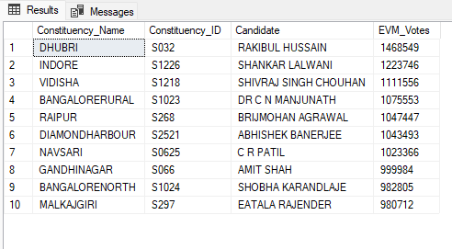

Which candidate won and which candidate was the runner-up in each constituency of State for the 2024 elections?
WITH RankedCandidates AS (
SELECT
cd.Constituency_ID,
cd.Candidate,
cd.Party,
cd.EVM_Votes,
cd.Postal_Votes,
cd.EVM_Votes + cd.Postal_Votes AS Total_Votes,
ROW_NUMBER() OVER (PARTITION BY cd.Constituency_ID ORDER BY cd.EVM_Votes + cd.Postal_Votes DESC) AS VoteRank
FROM
constituencywise_details cd
JOIN
constituencywise_results cr ON cd.Constituency_ID = cr.Constituency_ID
JOIN
statewise_results sr ON cr.Parliament_Constituency = sr.Parliament_Constituency
JOIN
states s ON sr.State_ID = s.State_ID
WHERE
s.State = ' Uttar Pradesh'
)

SELECT
cr.Constituency_Name,
MAX(CASE WHEN rc.VoteRank = 1 THEN rc.Candidate END) AS Winning_Candidate,
MAX(CASE WHEN rc.VoteRank = 2 THEN rc.Candidate END) AS Runnerup_Candidate
FROM
RankedCandidates rc
JOIN
constituencywise_results cr ON rc.Constituency_ID = cr.Constituency_ID
GROUP BY
cr.Constituency_Name
ORDER BY
cr.Constituency_Name;

Query Explaination:

1. Common Table Expression (CTE) RankedCandidates
- WITH RankedCandidates AS: This section creates a Common Table Expression (CTE) named RankedCandidates, which is used to rank candidates based on their total votes within each constituency.
- SELECT ... FROM constituencywise_details cd: This part of the CTE retrieves data from the constituencywise_details table, including:
  - cd.Constituency_ID: The ID of the constituency.
  - cd.Candidate: The name of the candidate.
  - cd.Party: The party of the candidate.
  - cd.EVM_Votes: The number of EVM votes received by the candidate.
  - cd.Postal_Votes: The number of postal votes received by the candidate.
  - cd.EVM_Votes + cd.Postal_Votes AS Total_Votes: The total votes received by the candidate (sum of EVM and postal votes).
- ROW_NUMBER() OVER (PARTITION BY cd.Constituency_ID ORDER BY cd.EVM_Votes + cd.Postal_Votes DESC) AS VoteRank:
  - ROW_NUMBER() is a window function that assigns a unique rank to each candidate within their respective constituency.
  - PARTITION BY cd.Constituency_ID ensures that the ranking is done separately for each constituency.
  - ORDER BY cd.EVM_Votes + cd.Postal_Votes DESC orders candidates by their total votes in descending order, so the candidate with the most votes gets rank 1.
- JOIN ... ON ...: Joins are performed to combine information from related tables:
  - constituencywise_results cr ON cd.Constituency_ID = cr.Constituency_ID
  - statewise_results sr ON cr.Parliament_Constituency = sr.Parliament_Constituency
  - states s ON sr.State_ID = s.State_ID
- WHERE s.State = 'Maharashtra': Filters the results to include only data related to the state of Maharashtra.

2. Main Query
- SELECT ... FROM RankedCandidates rc: The main query retrieves data from the RankedCandidates CTE to find the winning and runner-up candidates for each constituency.
- MAX(CASE WHEN rc.VoteRank = 1 THEN rc.Candidate END) AS Winning_Candidate:
  - CASE WHEN rc.VoteRank = 1 THEN rc.Candidate END selects the candidate with the highest vote rank (rank 1) for each constituency.
  - MAX(...) ensures that only one candidate is selected for each constituency.
- MAX(CASE WHEN rc.VoteRank = 2 THEN rc.Candidate END) AS Runnerup_Candidate:
  - CASE WHEN rc.VoteRank = 2 THEN rc.Candidate END selects the candidate with the second highest vote rank (rank 2) for each constituency.
  - MAX(...) ensures that only one candidate is selected for each constituency.
- JOIN ... ON ...: Joins the RankedCandidates CTE with the constituencywise_results table to get the constituency names.
- GROUP BY cr.Constituency_Name: Groups the results by constituency name to ensure that the winning and runner-up candidates are determined for each constituency.
- ORDER BY cr.Constituency_Name: Orders the results alphabetically by constituency name for easier readability.

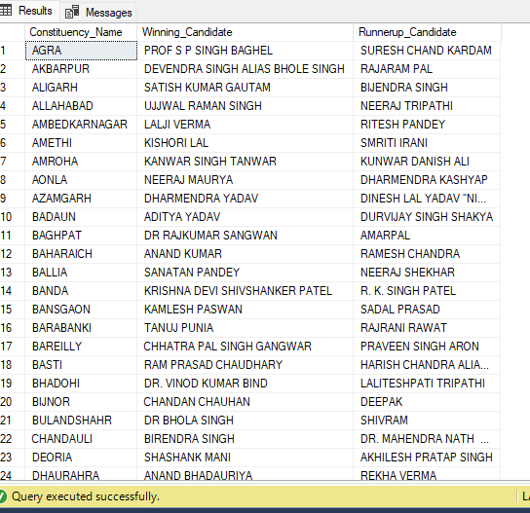

For the state of Maharashtra, what are the total number of seats, total number of candidates, total number of parties, total votes (including EVM and postal), and the breakdown of EVM and postal votes?
SELECT
COUNT(DISTINCT cr.Constituency_ID) AS Total_Seats,
COUNT(DISTINCT cd.Candidate) AS Total_Candidates,
COUNT(DISTINCT p.Party) AS Total_Parties,
SUM(cd.EVM_Votes + cd.Postal_Votes) AS Total_Votes,
SUM(cd.EVM_Votes) AS Total_EVM_Votes,
SUM(cd.Postal_Votes) AS Total_Postal_Votes
FROM
constituencywise_results cr
JOIN
constituencywise_details cd ON cr.Constituency_ID = cd.Constituency_ID
JOIN
statewise_results sr ON cr.Parliament_Constituency = sr.Parliament_Constituency
JOIN
states s ON sr.State_ID = s.State_ID
JOIN
partywise_results p ON cr.Party_ID = p.Party_ID
WHERE
s.State = ' Uttar Pradesh';
